Road Accident Analysis SQL Report

1. Total casualties for current year.

SELECT SUM(number_of_casualties) AS CY_Casualties

FROM [dbo].[road_accident] Where YEAR (accident_date) = '2022'



1. Total accident for current year.

SELECT count(accident_index) AS CY_Accidents

FROM [dbo].[road_accident] Where YEAR (accident_date) = '2022'



1. Total Casualties by accident severity Fatal.

SELECT sum(number_of_casualties) AS CY_Fatal_Casualties

FROM [dbo].[road_accident] Where YEAR (accident_date) = '2022' AND accident_severity = 'Fatal'

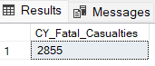

1. Total Casualties by accident severity Serious.

SELECT sum(number_of_casualties) AS CY_Serious_Casualties

FROM [dbo].[road_accident] Where YEAR (accident_date) = '2022' AND accident_severity = 'Serious'

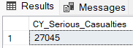

1. Total Casualties by accident severity Slight.

SELECT sum(number_of_casualties) AS CY_slight_Casualties

FROM [dbo].[road_accident] Where YEAR (accident_date) = '2022' AND

accident_severity = 'Slight'

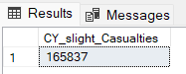

1. Total Casualties with respect to vehicle type for current year.

SELECT

CASE

WHEN vehicle_type IN ('Agricultural vehicle') Then 'Agricultural'

WHEN vehicle_type IN ('Motorcycle over 500cc', 'Motorcycle 125cc and under','Motorcycle 50cc and under', 'Motorcycle over 125cc and up to 500cc','Pedal cycle') Then 'Motorcycle'

WHEN vehicle_type IN ('Bus or coach (17 or more pass seats)', 'Minibus (8 - 16 passenger seats)') THEN 'BUS'

WHEN vehicle_type IN ('Car', 'Taxi/Private hire car') Then 'Car'

WHEN vehicle_type IN ('Van / Goods 3.5 tonnes mgw or under','Goods over 3.5t. and under 7.5t','Goods 7.5 tonnes mgw and over') Then 'Van'

ELSE 'Other'

END as vehicle_group,sum(number_of_casualties) AS CY_slight_Casualties

FROM [dbo].[road_accident] Where YEAR (accident_date) = '2022'

Group By

CASE

WHEN vehicle_type IN ('Agricultural vehicle') Then 'Agricultural'

WHEN vehicle_type IN ('Motorcycle over 500cc', 'Motorcycle 125cc and under', 'Motorcycle 50cc and under', 'Motorcycle over 125cc and up to 500cc','Pedal cycle') Then 'Motorcycle'

WHEN vehicle_type IN ('Bus or coach (17 or more pass seats)', 'Minibus (8 - 16 passenger seats)') THEN 'BUS'

WHEN vehicle_type IN ('Car', 'Taxi/Private hire car') Then 'Car'

WHEN vehicle_type IN ('Van / Goods 3.5 tonnes mgw or under','Goods over 3.5t. and under 7.5t','Goods 7.5 tonnes mgw and over') Then 'Van'

ELSE 'Other'

END

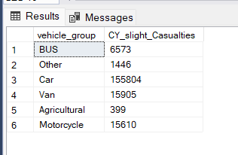

1. Monthly trend showing comparison for current Year and Previous Year

Select DATENAME(Month, accident_date) as Month_Name

SUM(number_of_casualties) As Cy_Casualtie

From [dbo].[road_accident] Where Year(accident_date) = '2022'

Group by DATENAME(Month, accident_date)

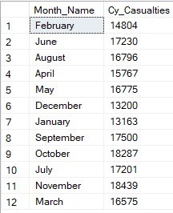

1. Casualties by Road Type for current year

Select road_type, SUM(number_of_casualties)

From [dbo].[road_accident] Where YEAR(accident_date) ='2022'

Group by road_type

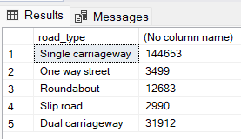

1. Current Year casualties by Area/Location & by Day/Night

Select urban_or_rural_area, CAST(sum(number_of_casualties) AS decimal(10,2))*100 /

(Select CAST(sum(number_of_casualties) AS decimal(10,2)) From [dbo].[road_accident] Where YEAR (accident_date) = '2022')

From [dbo].[road_accident] Where YEAR (accident_date) = '2022'

Group by urban_or_rural_area

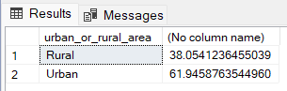

Select

CASE

WHEN light_conditions IN ('Darkness - lights lit', 'Darkness - lights unlit', 'Darkness - lighting unknown', 'Darkness - no lighting') Then 'Night'

WHEN light_conditions IN ('Daylight') Then 'Day'

END AS Light_Condition,

CAST(CAST (sum (number_of_casualties) As Decimal (10,2)) *100/

(Select CAST (sum (number_of_casualties) As Decimal (10,2))

From [dbo].[road_accident] Where YEAR(accident_date) ='2022') As Decimal (10,2))

AS CY_Casualties_PCT

From [dbo].[road_accident] Where YEAR(accident_date) ='2022'

Group By

CASE

WHEN light_conditions IN ('Darkness - lights lit', 'Darkness - lights unlit', 'Darkness - lighting unknown', 'Darkness - no lighting') Then 'Night'

WHEN light_conditions IN ('Daylight') Then 'Day'

END

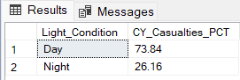

7- Total Casualties and by location.

Select Top 15 local_authority, Sum(number_of_casualties) As Total_Casualties

From [dbo].[road_accident]

Group by local_authority

Order by Total_Casualties DESC

